**Displaying Score**

**(This will show you how to display the number of items you have collected)**

1. **Open the PlayerControll Script.**

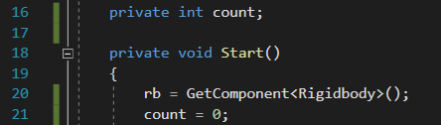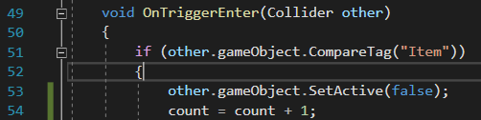

Line 16 Reference to count value.

Line 21 Value of count.

Line 54 Adding value.

1. **Create UI Text.**

Hierarchy—Create— UI—Text.

Rename the text from the Hierarchy to Count Text.

Changer the colour to white or black(Depends on your camera) under the Text (Script).

Change the text under the Text (Script) to Count and Font Size to the value of 20.

1. **Position the Text (Count Text) On the left Top of the Screen.**

Select Count Text from the Hierarchy, under Rect Transform left click the big box, press down shift+alt and choose the top left box.

Change the Pos X value to 10 and the Pos Y to -10.

1. **Open PlayerControll Script and Edit.**

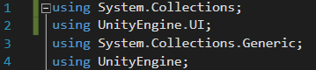



Line 2 Opens the name face of UI.

Line 13 Reference to UI text.

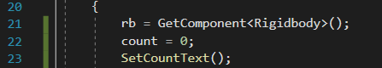

Line 23 Reference to the function.

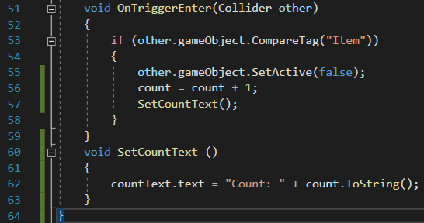

Line 57 Reference to the function.

Line 60 Function.

Line 62 Text Property.